EXPERIMENT-8

AIM : Write SQL queries to perform ORACLE BUILT-IN FUNCTIONS (i.e. DATE, TIME).

**Built-in Functions :**

1. **Character Functions** 
   1. **Case-conversion functions**
   2. **Character manipulation functions**
2. **Number Functions**
3. **DATE functions**

CREATING TABLE :

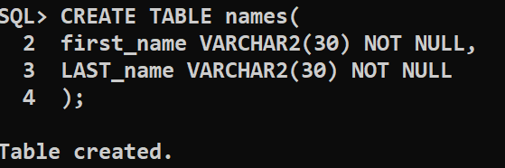

INSERTING VALUES :

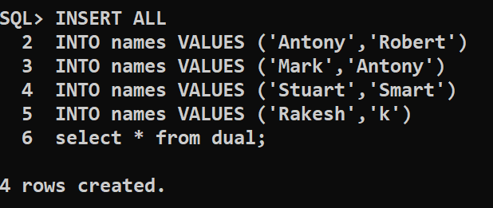

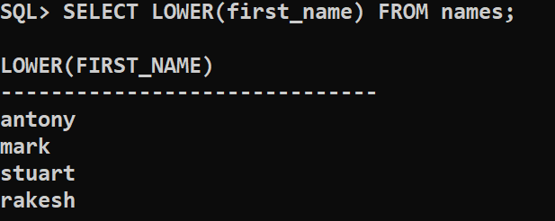

# Character Functions

**I. Case-conversion functions :**

*LOWER ();*

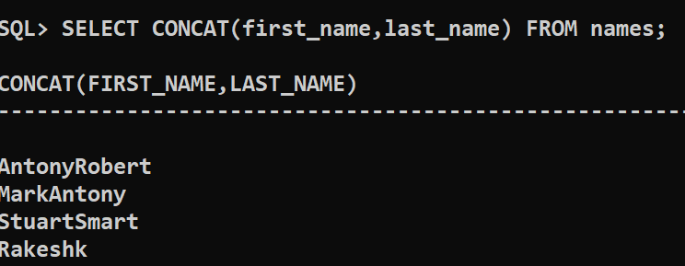

*UPPER();*

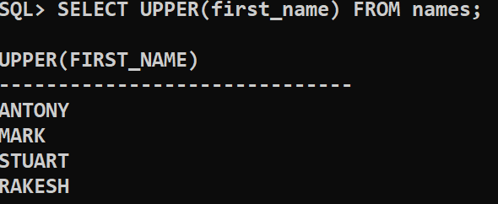

*INITCAP();*

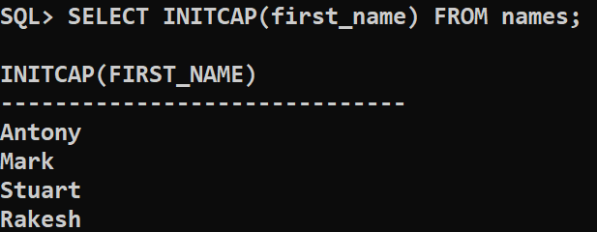

**Character manipulation functions:**

***CONCAT():***



***SUBSTR():***

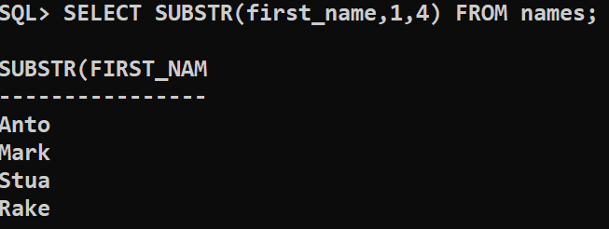

LENGTH() :

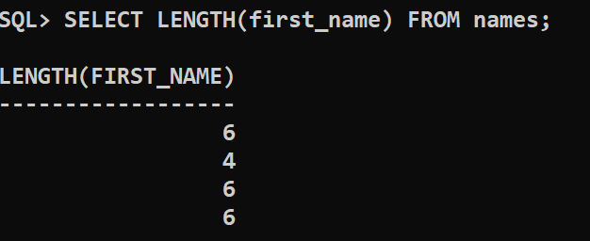

INSTR() :

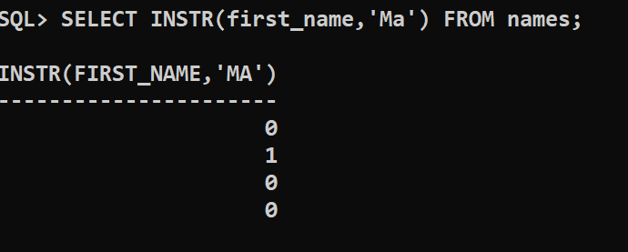

TRIM() :

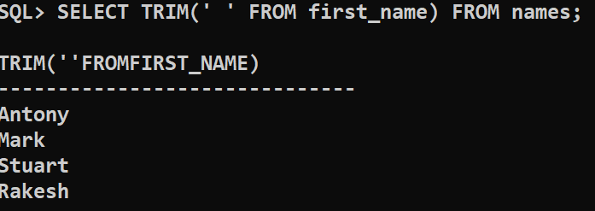

**2. Number Functions :**

ROUND() :

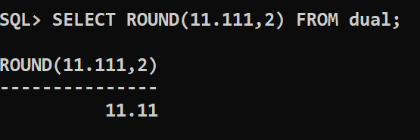

MOD() :

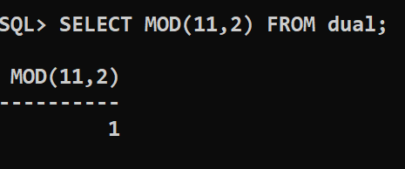

**2.DATE functions :**

SYSDATE() :

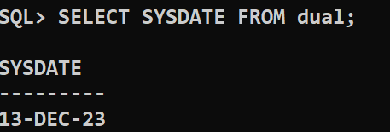

MONTHS-BETWEEN() :

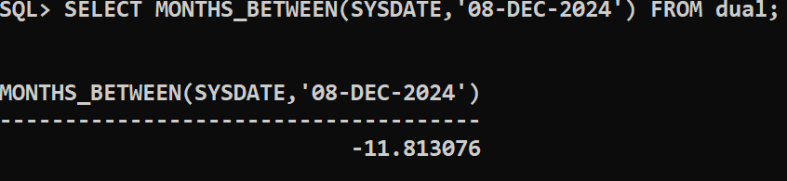

ADD_MONTHS() :

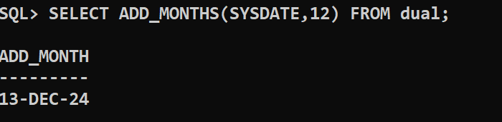

NEXT_DAY():

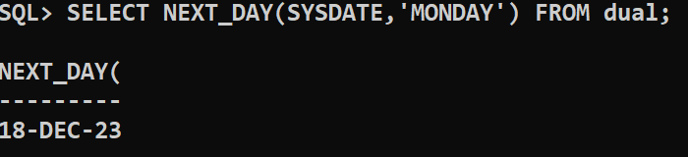

LAST_DAY() :

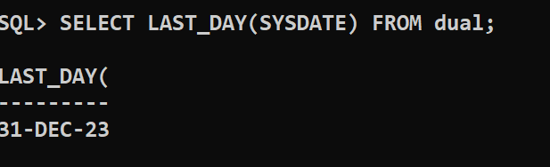

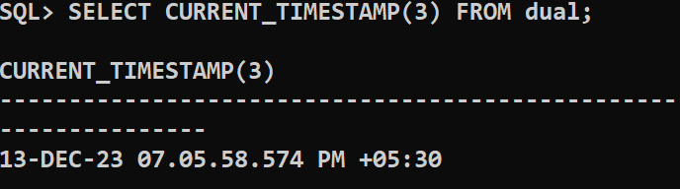

CONCLUSION : SQL queries to perform oracle built-in-functions are successfully executed.